Objective Questions (Each Questions carry 2 marks)

-------------------------------------------------------------------------------------------------------------------------------------------------------------------------------------------------------------------------------------------------------------------

Q1) What SQL statement would you use to create SQL database named Test?

a) CREATE DBT Test;

b) CREATE Test;

**c) CREATE DATABASE Test;**

d) MAKE DATABASE Test;

**ANS: c) CREATE DATABASE Test;**

Q2) What SQL statement would you use to remove SQL database named Test?

**a) DROP DATABASE Test;**

b) REMOVE Test;

c) DROP DBT Test;

d) REMOVE DATABASE Test;

**ANS: a) DROP DATABASE Test;**

Q3) Fulfill missing parts in SQL statement below to create Products table.

_____ **CREATE TABLE Products** ________ (

ProductID INT ____ **PRIMARY KEY**_______,

ProductName VARCHAR(255),

SupplierID INT,

CategoryID INT,

Unit ____ **VARCHAR(255)**_________**,**

Price _____**INT**________

);

Q4) Primary Key is a combination of two types of constraints. Find the correct one in the list below.

a) UNIQUE & DEFAULT

b) CHECK & UNIQUE

**c) UNIQUE & NOT NULL**

d) CHECK & AUTO INCREMENT

**ANS: c) UNIQUE & NOT NULL**

Q5) Which field in the Orders table has a role of FOREIGN KEY in relation to Customers table?

**a) CustomerID**

b) OrderID

c) OrderDate

d) CustomerName

**ANS: a) CustomerID**

Q6) What SQL statement would you use to put a new record into the Orders table?

**a) INSERT INTO Orders (OrderID, CustomerID, OrderDate) VALUES (200, 125, '2018-02-05');**

b) PUT INTO Orders (OrderID, CustomerID, OrderDate) VALUES (200, 125, '2018-02-05');

c) INSERT VALUES (200, 125, '2018-02-05') INTO Orders (OrderID, CustomerID, OrderDate);

d) PUT VALUES (200, 125, '2018-02-05') INTO Orders (OrderID, CustomerID, OrderDate);

**ANS: a) INSERT INTO Orders (OrderID, CustomerID, OrderDate) VALUES (200, 125, '2018-02-05');**

Q7) What SQL statement would you use to modify the existing record of CustomerID to 10 for OrderID #10308 in the Orders table?

a) CHANGE SET Orders CustomerID = 10 WHERE OrderID = 10308;

b) UPDATE SET Orders CustomerID = 10 WHERE OrderID = 10308;

c) CHANGE Orders SET CustomerID = 10 WHERE OrderID = 10308;

**d) UPDATE Orders SET CustomerID = 10 WHERE OrderID = 10308;**

**ANS: d) UPDATE Orders SET CustomerID = 10 WHERE OrderID = 10308;**

Q8) What SQL statement would you use to delete order with OrderID #10308 from the Orders table?

**a) DELETE FROM Orders WHERE OrderID = 10308;**

b) CUT FROM Orders WHERE OrderID = 10308;

c) MOVE Orders WHERE OrderID = 10308;

d) REMOVE FROM Orders WHERE OrderID = 10308;

**ANS: a) DELETE FROM Orders WHERE OrderID = 10308;**

Q9) What SQL statement would you use to add an Age field to the Customers table?

a) UPDATE TABLE Customers ADD Age INT;

**b) ALTER TABLE Customers ADD Age INT;**

c) UPDATE TABLE ADD Age INT Customers;

d) ALTER TABLE ADD Age INT Customers;

**ANS: b) ALTER TABLE Customers ADD Age INT;**

Q10) What SQL statement would you use to remove Customers table from Test database?

a) REMOVE TABLE Customers;

b) REMOVE Customers;

c) DROP Customers;

**d) DROP TABLE Customers;**

**ANS: d) DROP TABLE Customers;**

Q11) What SQL Clause is used with CREATE USER statement to change password at first login?

a) PASSWORD DECLINE

**b) PASSWORD EXPIRE**

c) PASSWORD EXPIRED

d) PASWORD CHANGE

**ANS: b) PASSWORD EXPIRE**

Q12) Fulfill missing parts in SQL statement below to unlock user account.

___**ALTER USER**___ 'Jhon'@'localhost' ____**PASSWORD EXPIRE**____;

Q13) Fullfill the missing parts in SQL statement below to Grant Create, Alter ans Drop privileges to user account 'Jhon' on all tables of 'prod' databases.

__**GRANT**___ create, alter, drop on ___**\*.\***_ to 'jhon'@'localhost';

Q14) Which SQL statement is used to take away the privileges from user account?

a) DENIED

**b) REVOKE**

c) ESCAPE

d) REVOKED

**ANS: b) REVOKE**

Q 15) Which SQL command need to execute after every UPDATE statement to make changes permanenet.

a) ROLLBACK

b) SAVEPOINT

**c) COMMIT**

d) NONE

**ANS: c) COMMIT**

-------------------------------------------------------------------------------------------------------------------------------------------------------------------------------------------------------------------------------------------------------------------

Descriptive Qustions (Each Questions carry 5 marks)

-------------------------------------------------------------------------------------------------------------------------------------------------------------------------------------------------------------------------------------------------------------------

Q1) Using ER-Diagram to design an efficient Data Model by Employees and Department Entities. Attributes are given below with their respective entities

for your reference.

Entity 1: Employees

Attributes: Emp_ID, Emp_Name, Address, Contact, Salary, Dept_id

Entity 2: Department

Attributes: Dept_ID, Dept_Name

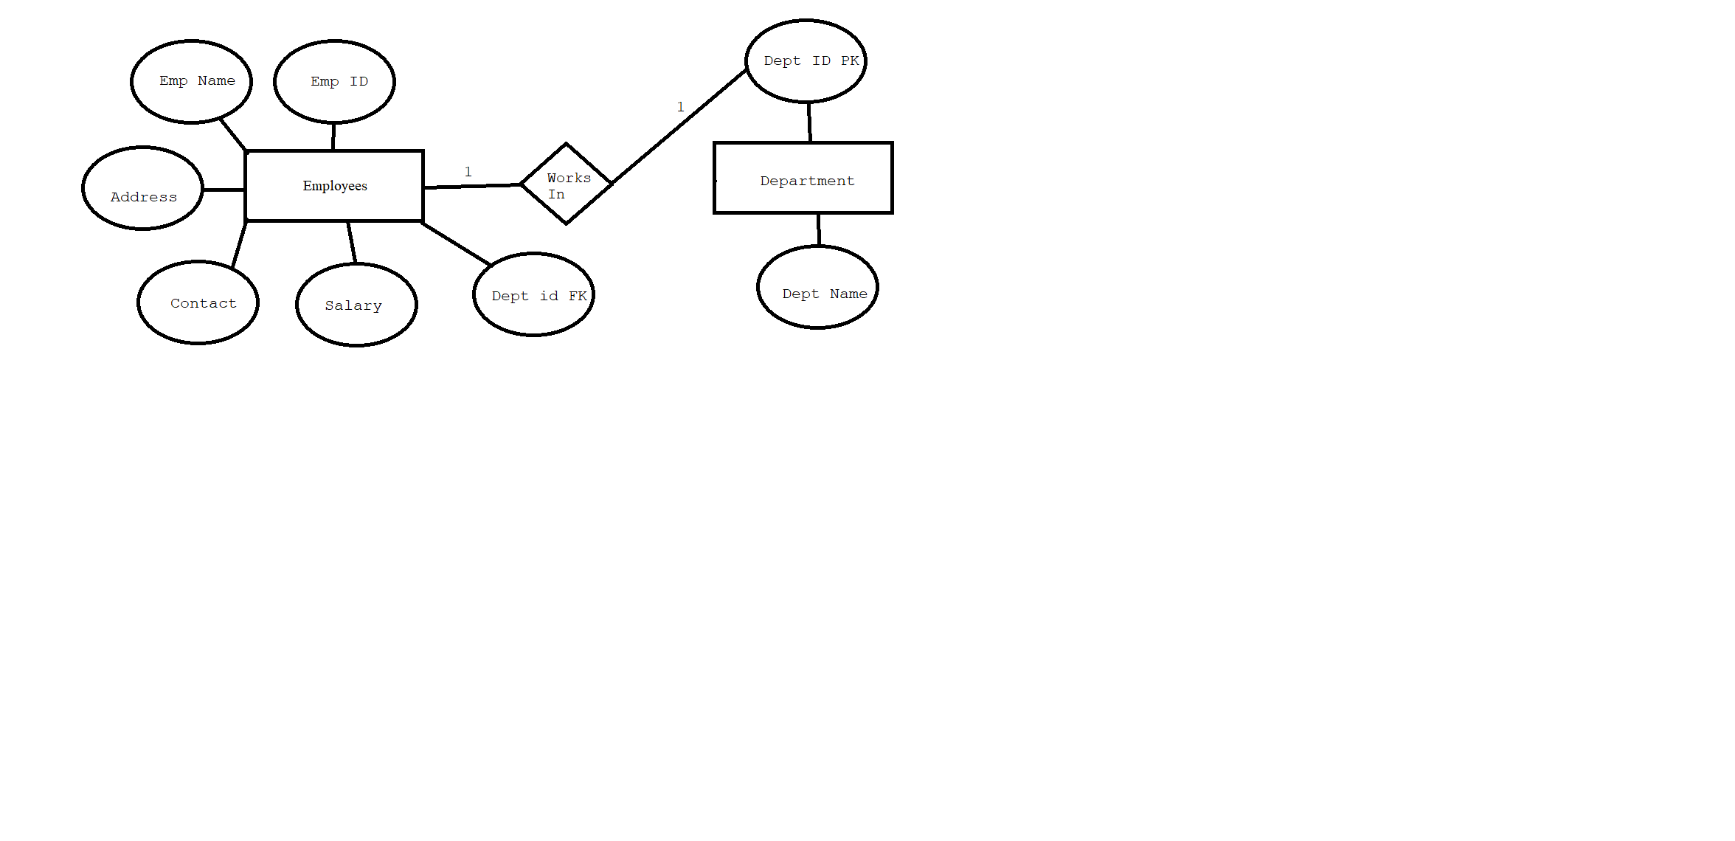

Q2) Transform the Previously designed ER Data Model into RDBMs Tabular Format.

